1.Jenkins Installation

Step1: Go to the download link https://jenkins-ci.org/.

1). Click on the above link and we can get the home page of the Jenkins
official website as shown below.

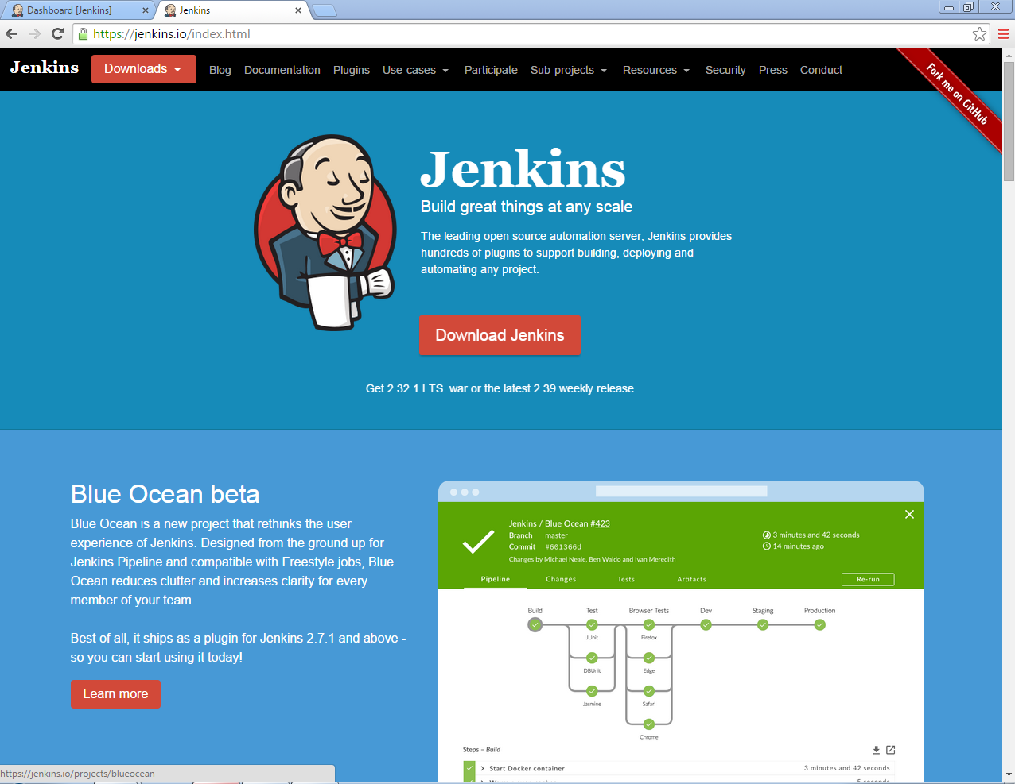

2). Click on Download button the latest release and the Long-Term support
release will be available for download. The past releases are also available
for download. Click on 2.32.1.war file downloading is started as shown:

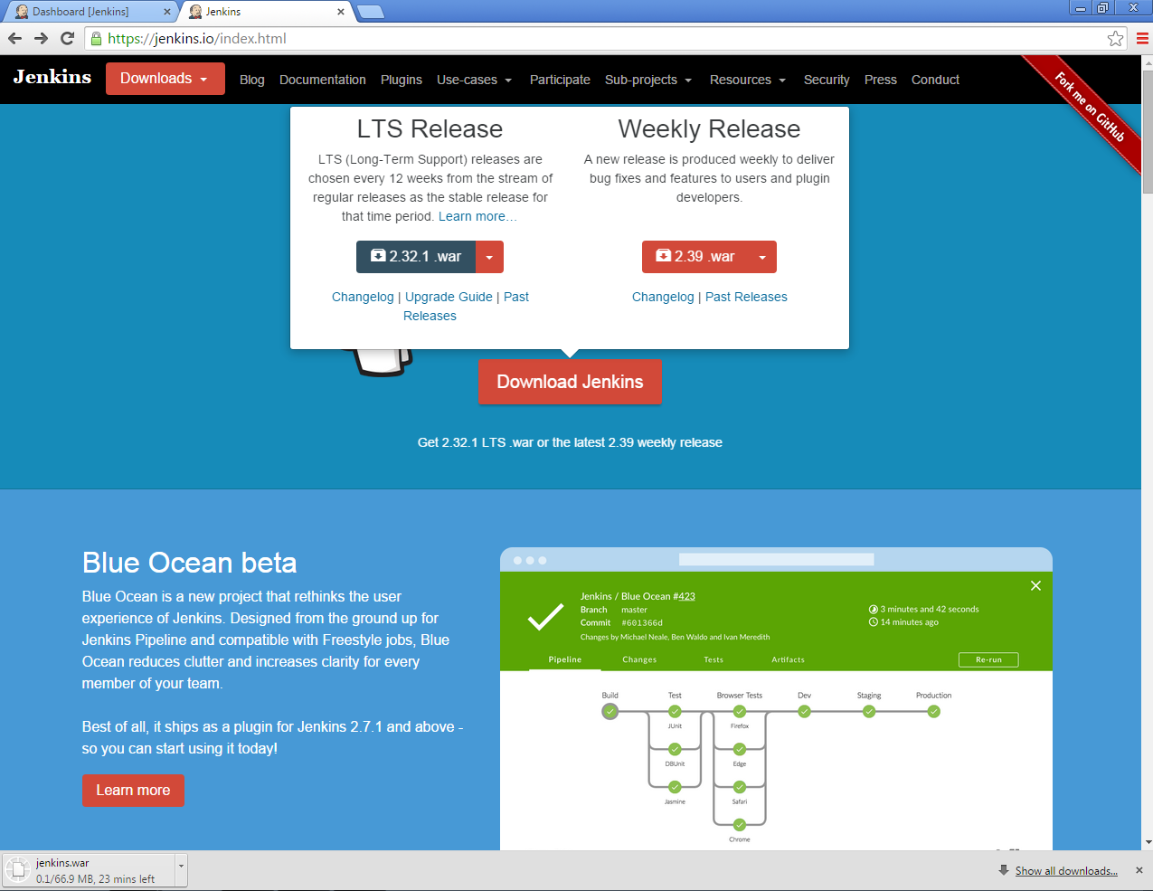

Step2: Starting Jenkins

1). Open the command prompt and browse the directory where
Jenkins.war is present. Run the command As
D:\jenkins>java -jar jenkins.war

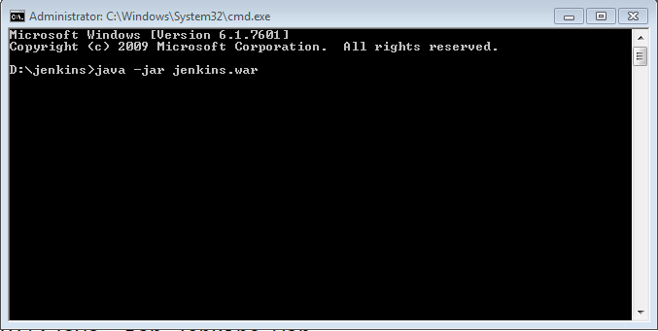
2). After the command is run, various tasks will run, one of which is the
extraction of the war file which is done by an embedded web server called
winstone as:
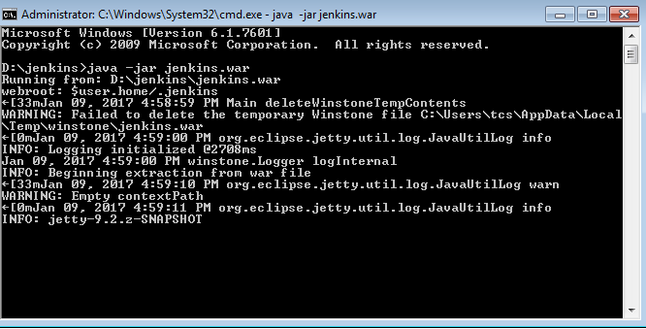

3). Once the processing is complete without major errors, one password is
generated and following line will come in the output of the command
prompt
INFO:Jenkins is fully up and running As
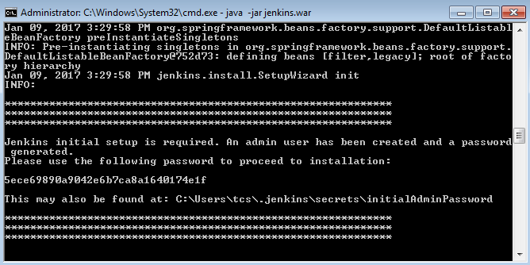

4). Copy the above password which is used to proceed to installation.

Password: 5ece69890a9042e6b7ca8a16400174e1f

Step3: Accessing Jenkins

1). Once Jenkins is up and running,go to the link http://localhost:8080
This will bring Jenkins login form:

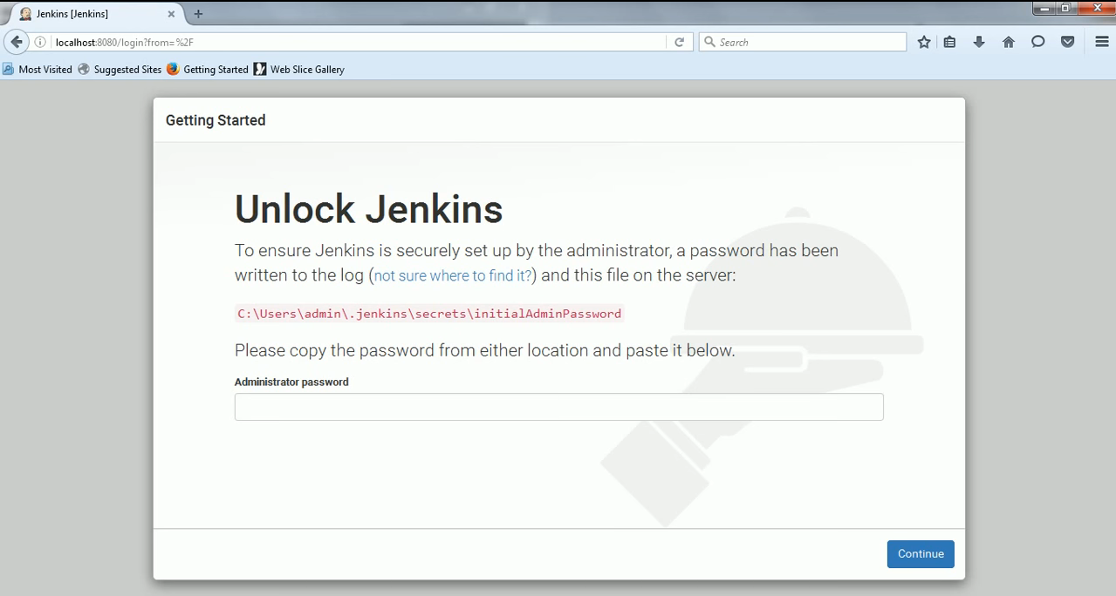
2). Enter password and click on continue button As:

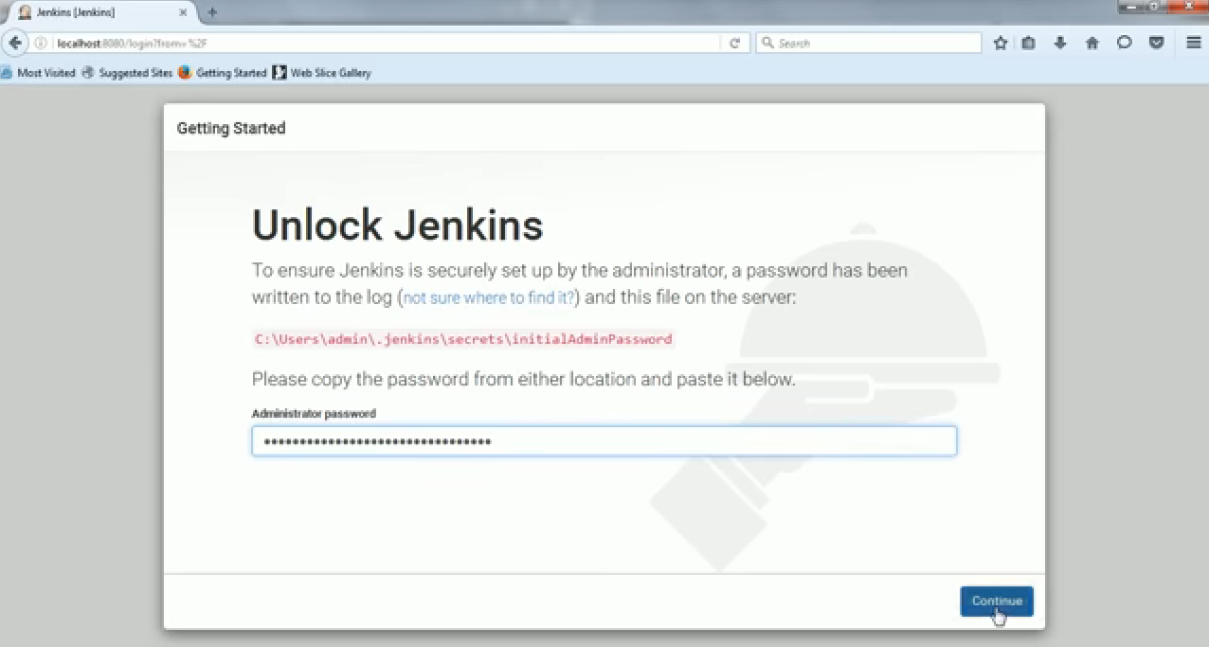

3). Once we click on continue button a fresh getting started page is open
with Customize Jenkins into which we choose Install Suggested Plugins
shown As:

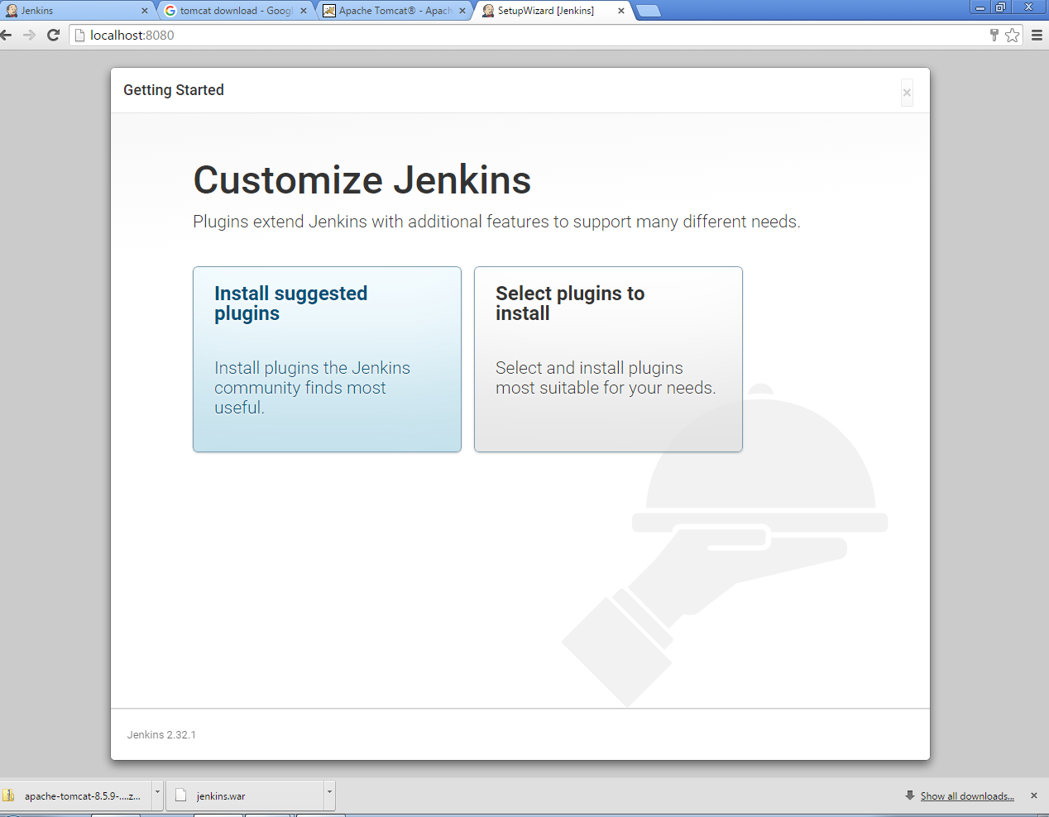

4). After clicking on install Suggested plugins all suggested plugins is going
to be downloaded as:
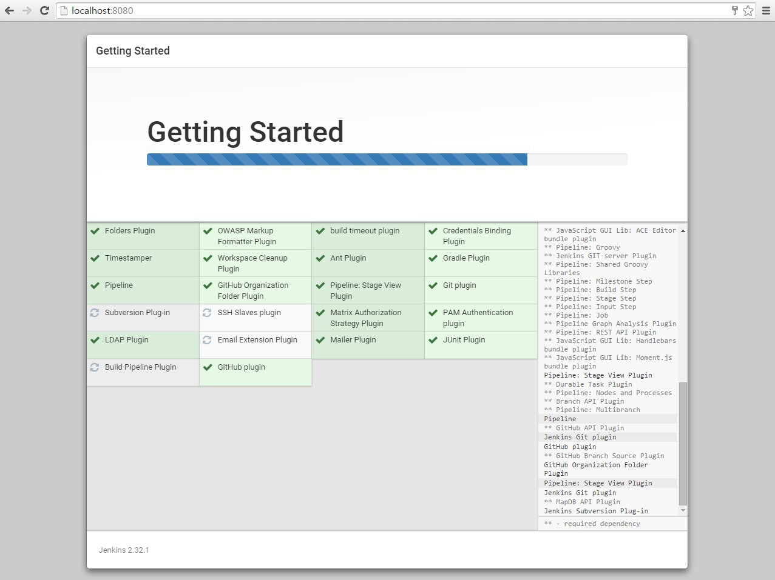

5). After downloading all plugins a fresh page getting started with Create
first admin user is opened as:

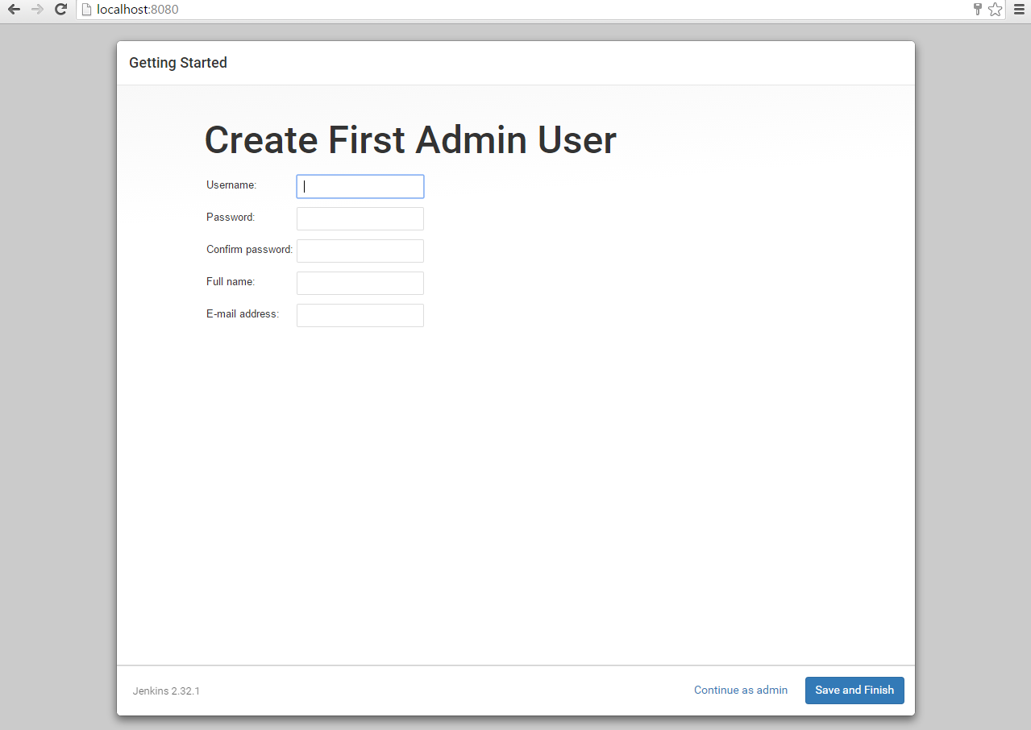
Create one username, password and filling all information we click on save
and finish button.

6). After clicking on save and finish a fresh Jenkins dashboard is open as:
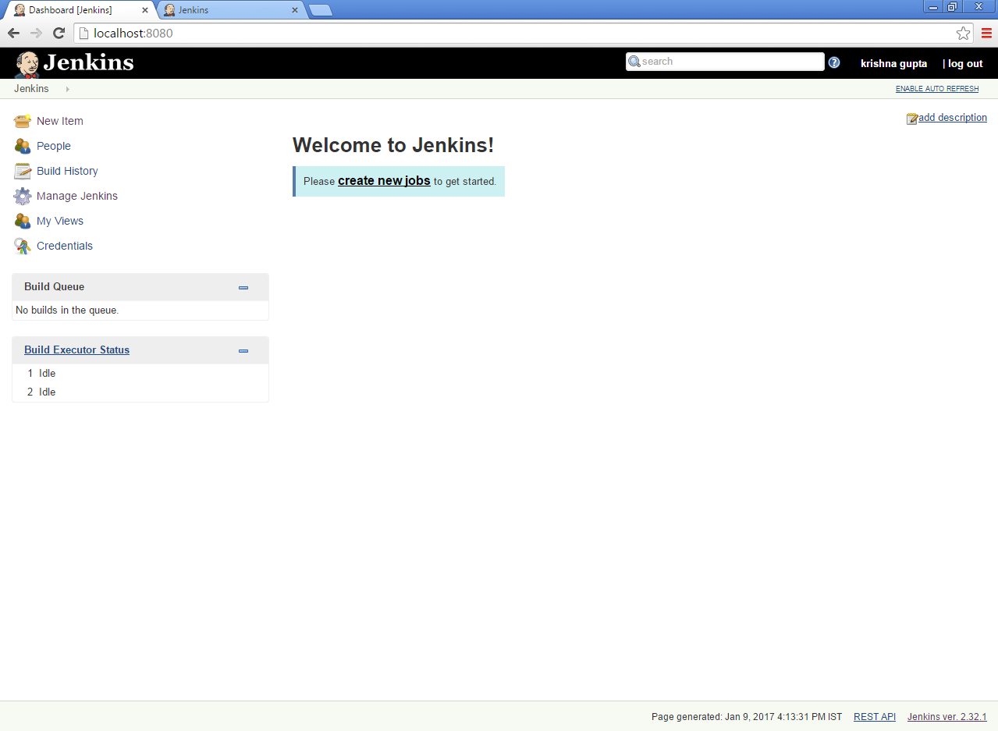

Step4: Installing Jenkins as a window service

1). Click on manage Jenkins on the left-hand side of a menu a list of services
are open as:

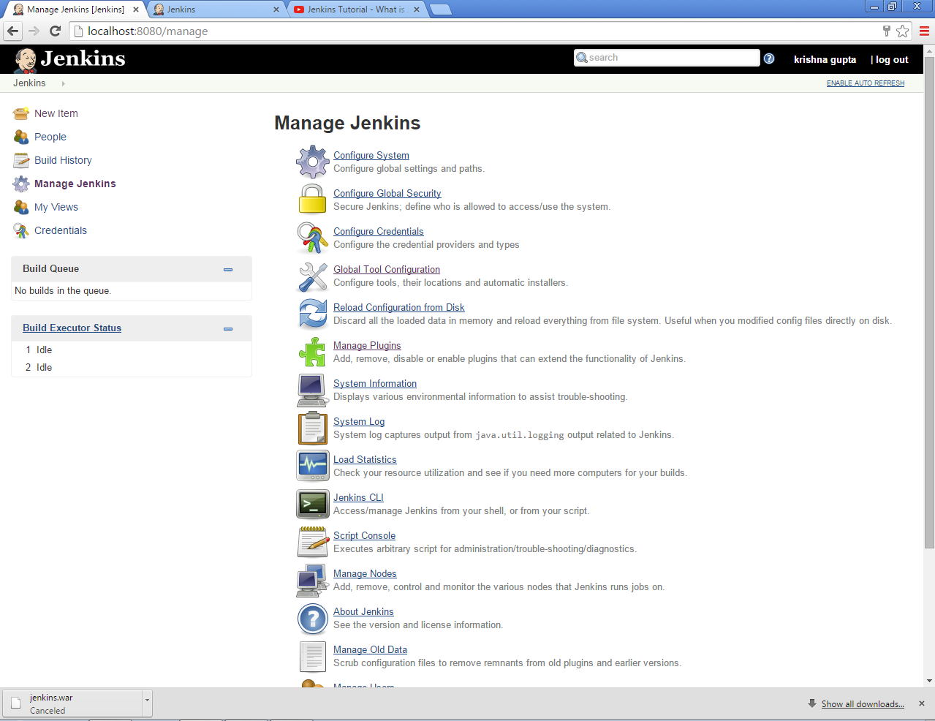

2). Into which we click on Install as window services.

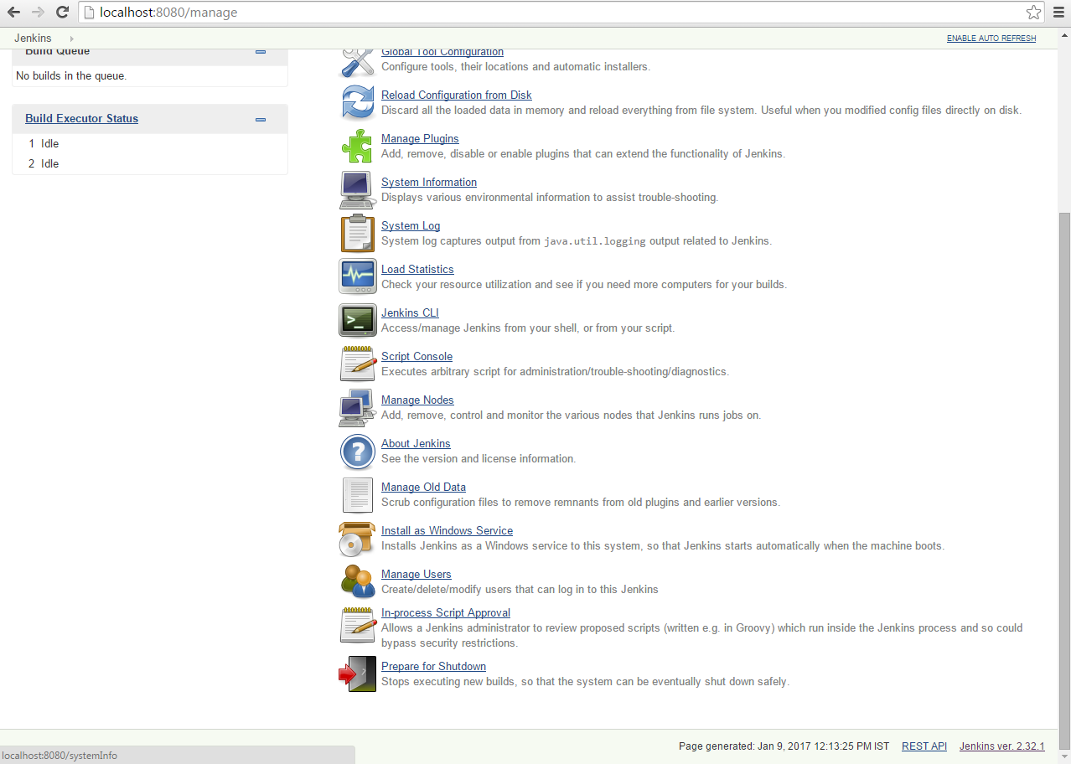

3). After clicking a new page is open with Installation Directory and we click
on install button as:

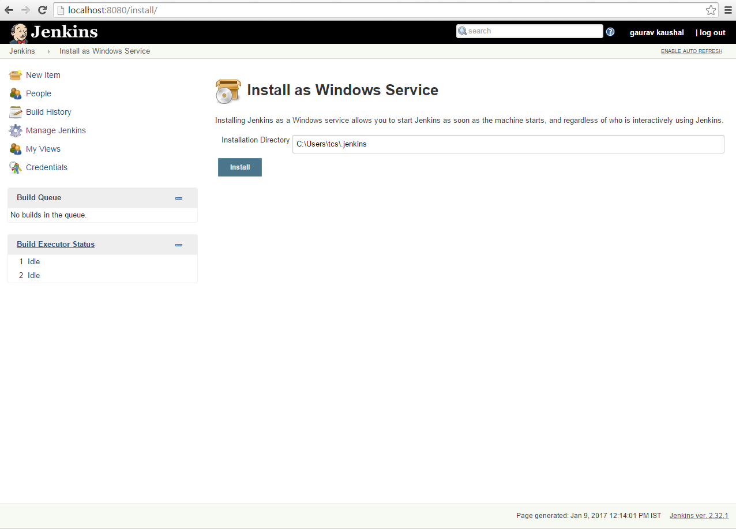
4). After click on install button a page with Installation complete message is
opened into which we click on yes as:
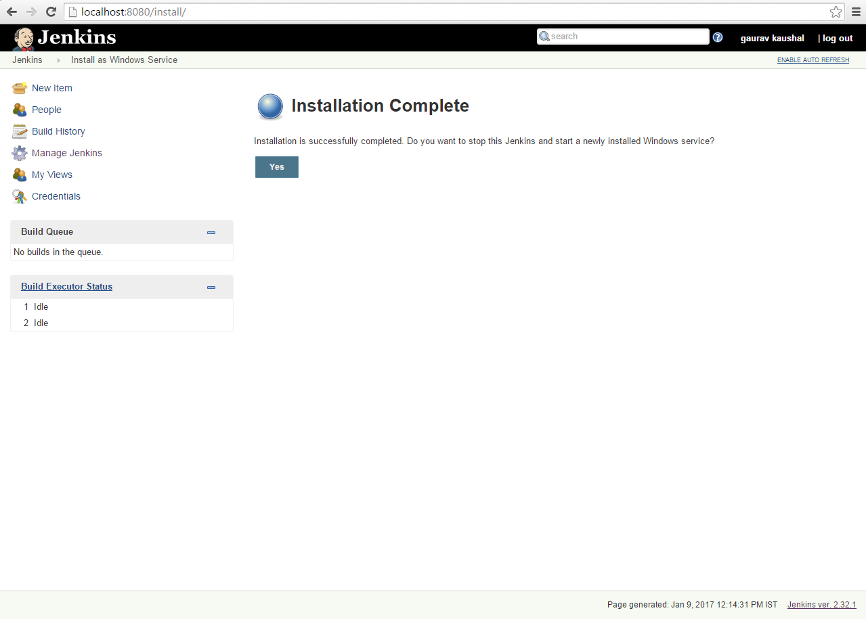

5). Once we click on yes button a new page is open as:

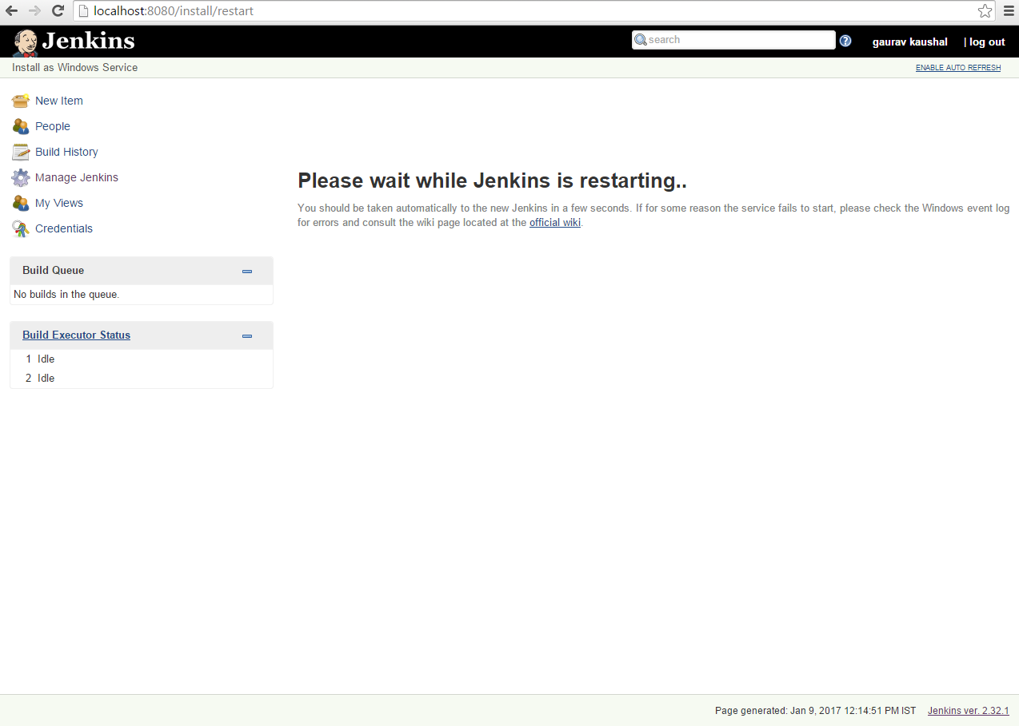
6). After waiting some minutes a new window form is open after login we
use Jenkins as a window service as:

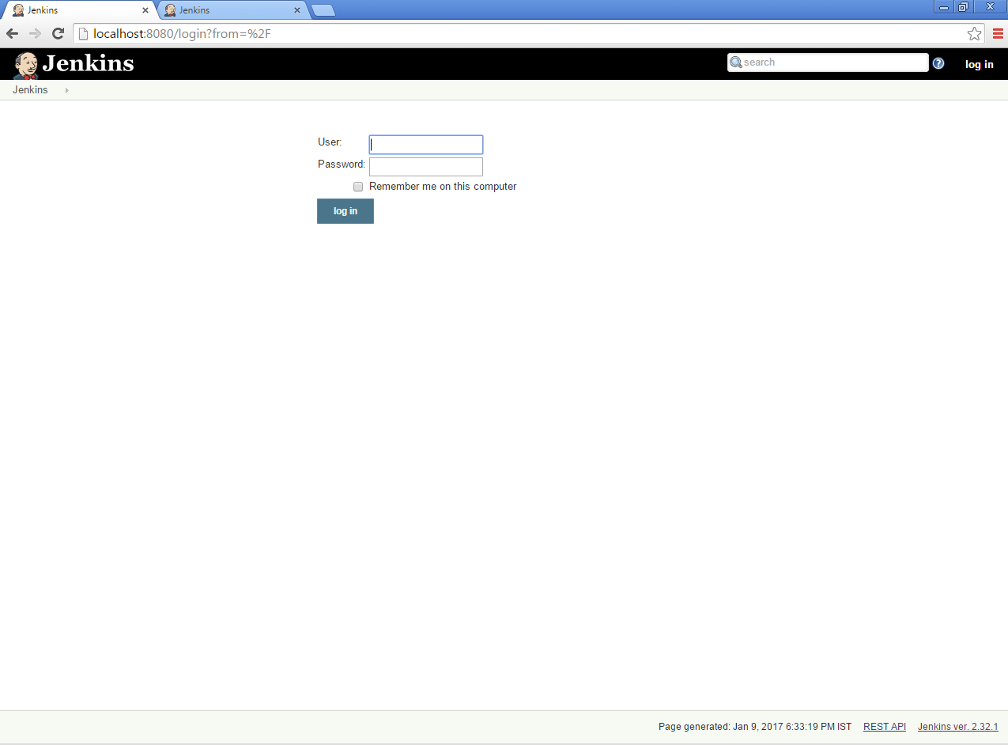

2. Jenkins – Tomcat Setup

The following prerequisites must be met for Jenkins Tomcat setup.

Step 1: Verifying Java Installation
To verify Java installation, open the console and execute the following java
command :
\>java –version
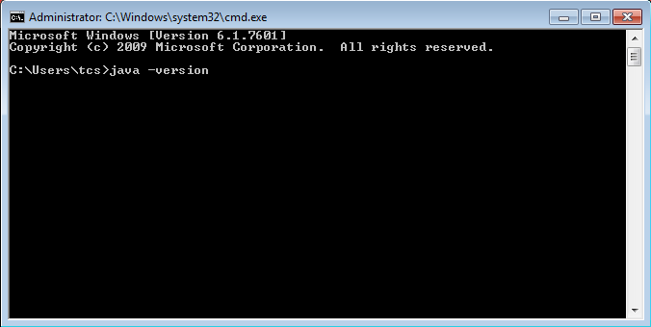
. If Java has been installed properly on your system, then you should get one of
the following outputs, depending on the platform you are working on.
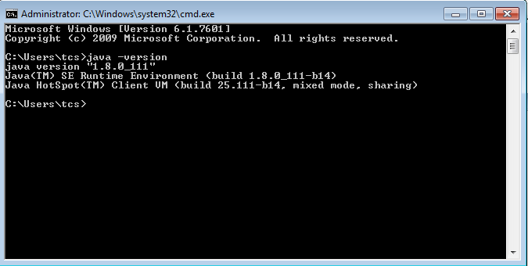

Step 2: Verifying Java Installation
Append the full path of the Java compiler location to the System Path.

- Right Click on computer and click on properties .
- Click on Advance System Setting.

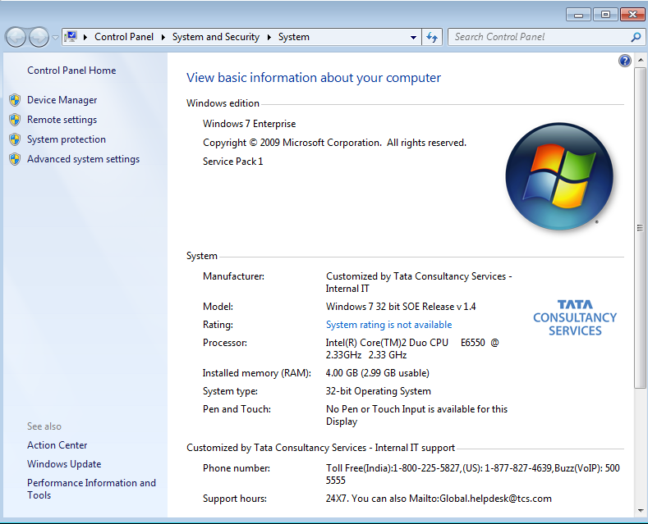
  - Click on Environment Variables.
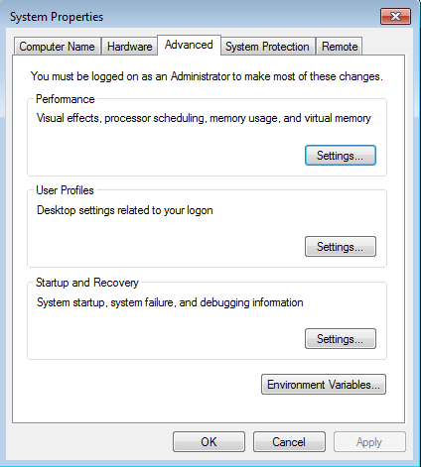

4). Set system variable JAVA_HOME to C:\Program Files\Java\jdk1.8.0_111
As:

  - Go to the directory where java installation is done.
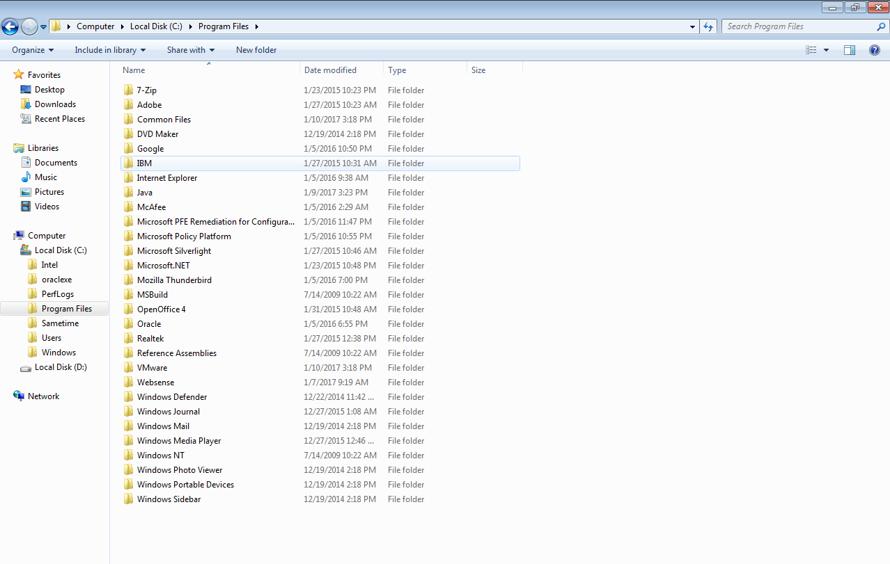

  - Click on java and then click on jdk1.8.0_111.

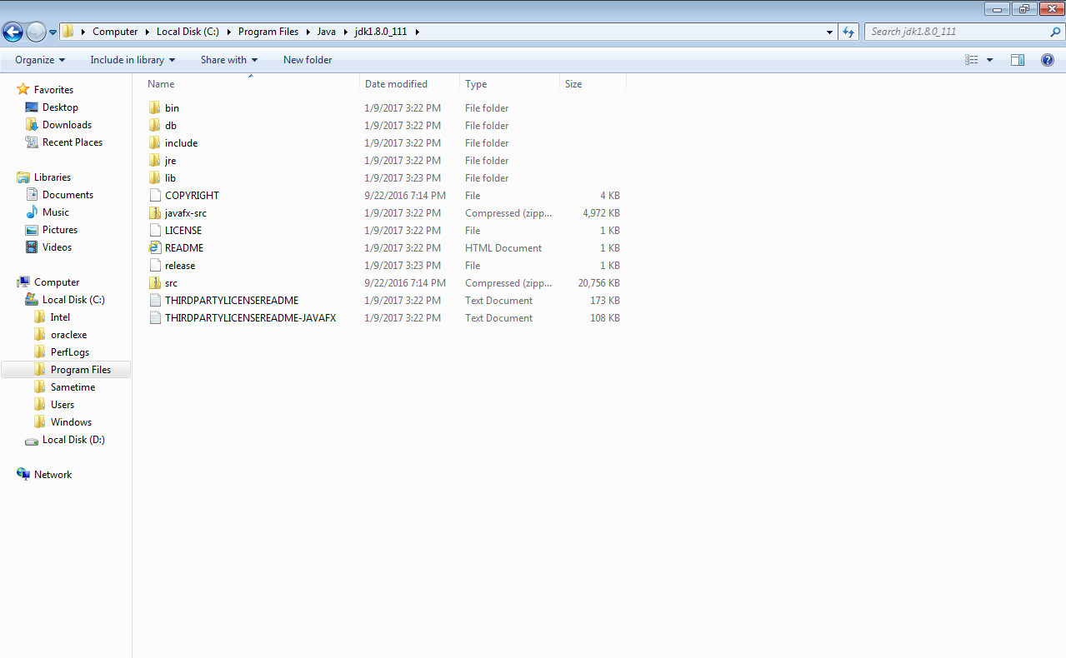

  - Copy the above path: C:\Program Files\Java\jdk1.8.0_111
and then go to environment variables click on new System
variable write variable name:JAVA_HOME and
variable value:paste above path
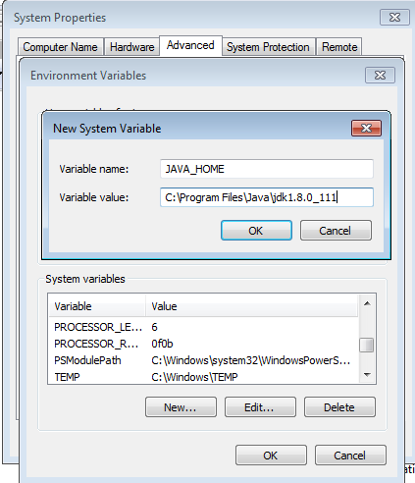
  - Click on bin folder as shown in step 4.2 and again copy path
as:C:\Program Files\Java\jdk1.8.0_111\bin then go to
environment variable click on new System variable write
variable name: PATH and variable value:paste above path as:
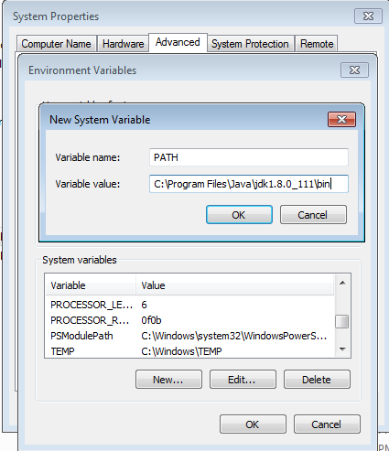
4.5). Click OK three times.

Step 3: Download Tomcat

  - Go to download link: http://tomcat.apache.org/. We click the above
link we can get the home page of the tomcat official website as shown below.

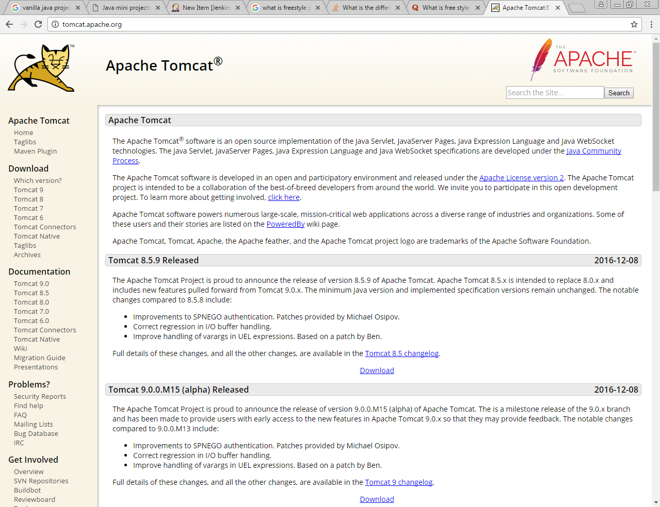
  - Click on download latest version which you want following page is shown as below:
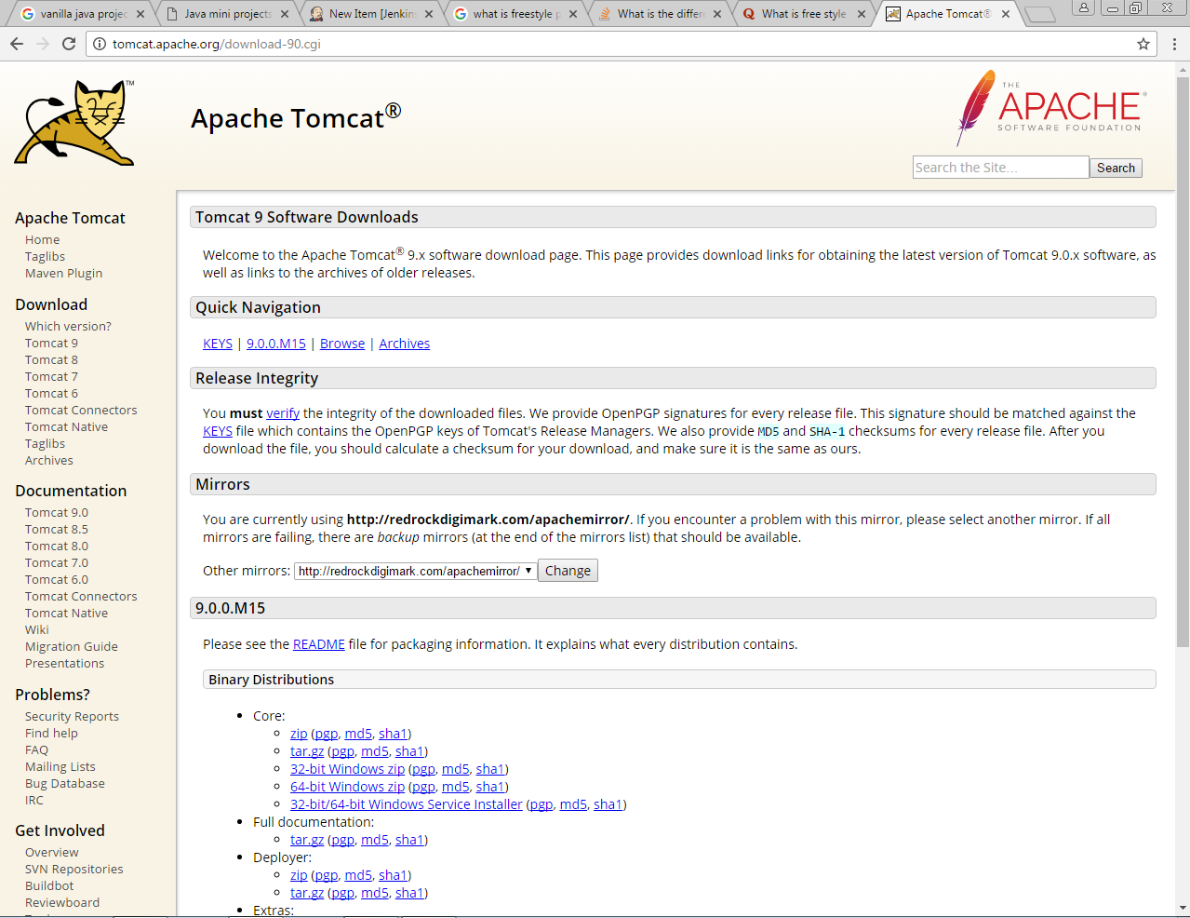

  - Go to the ‘Binary Distributions’ section. Download the 32-bit or 64 bit according to your system compatibility Windows zip file shown as:

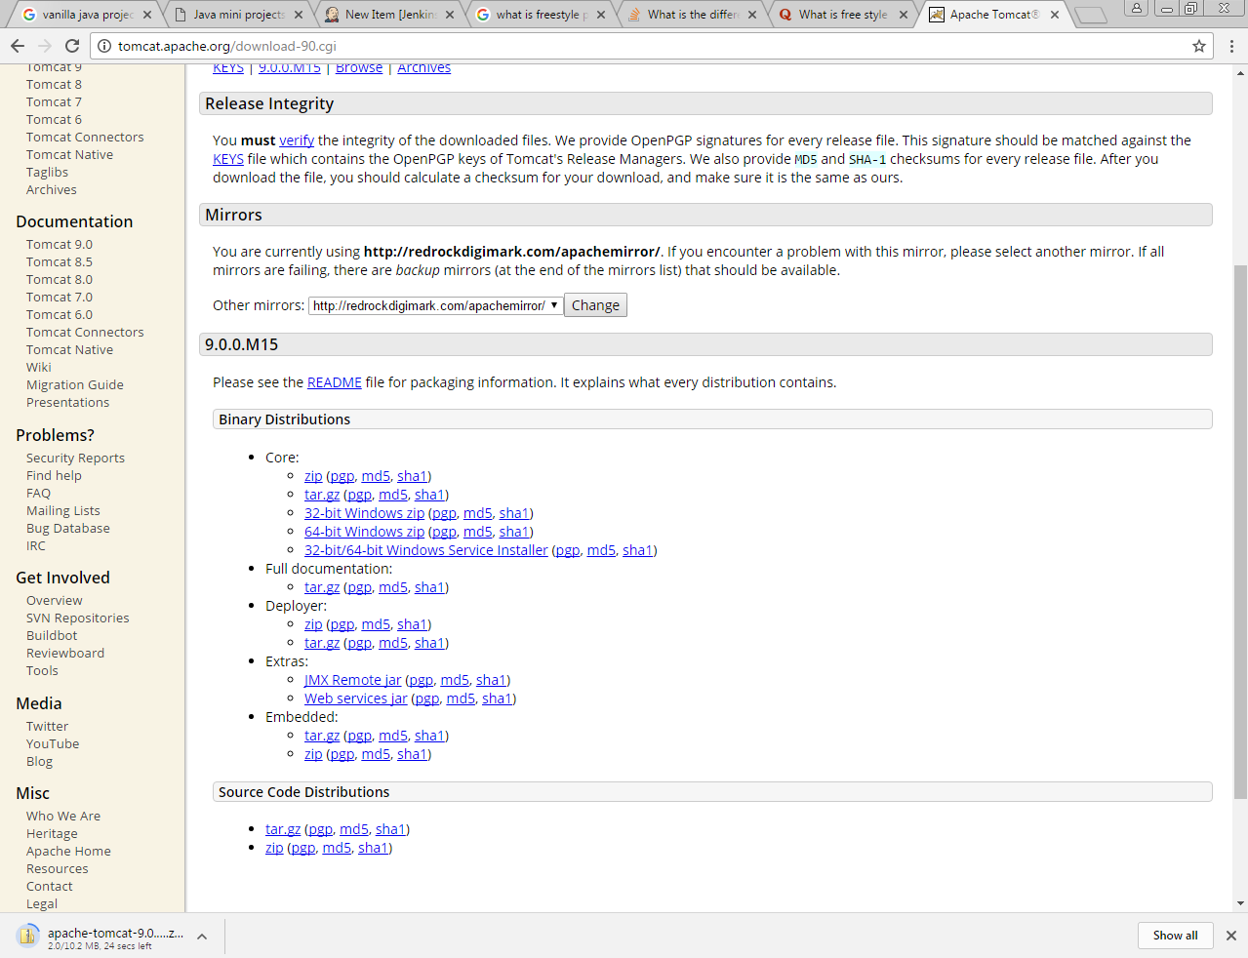
  - Then unzip the contents of the downloaded zip file in your desired folder.

Step 4: Jenkins and Tomcat Setup

- Copy the Jenkins.war file which was downloaded from the previous section and copy it to the webapps folder in the tomcat folder.
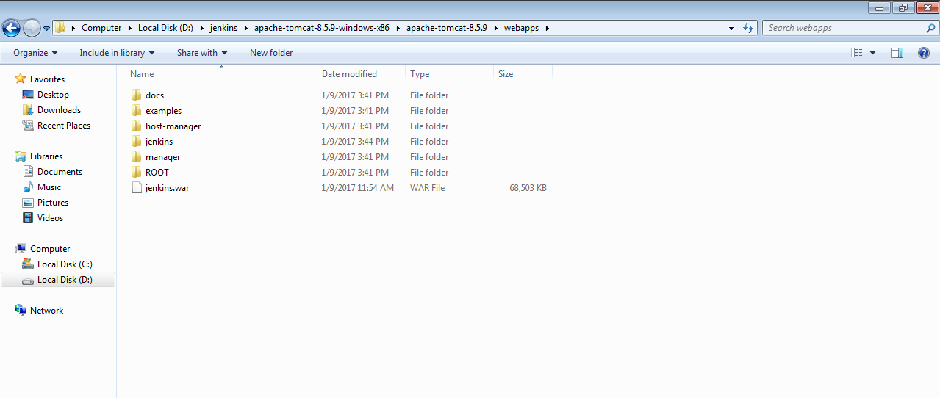

- Now open the command prompt. From the command prompt, browse to the
directory where the tomcat8.5.9 folder is located. Browse to the bin directory in this folder and run the command startup.bat as:
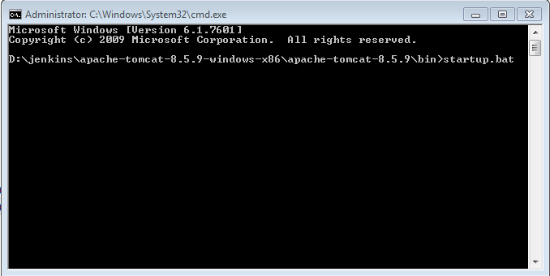

- Once the processing is complete without major errors, the following line will come in the output of the command prompt.
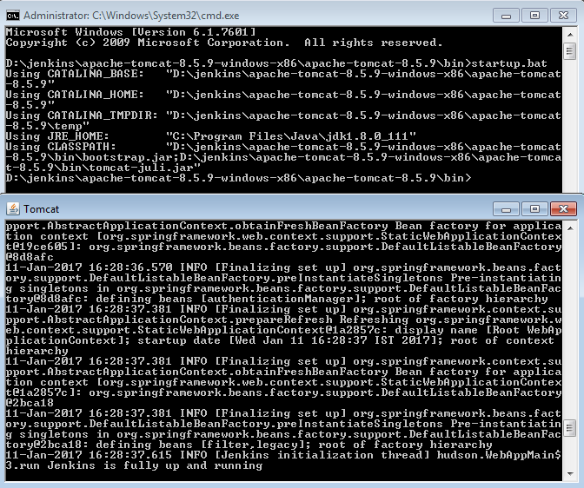

4).Above section show that Jenkins will be up and running on tomcat.

3. Jenkins – Maven Setup

Step 1: Downloading and Setting Up Maven

a)The official website for maven is https://maven.apache.org/download.cgi.
If we click the given link, you can get the home page of the maven official
website as shown below.

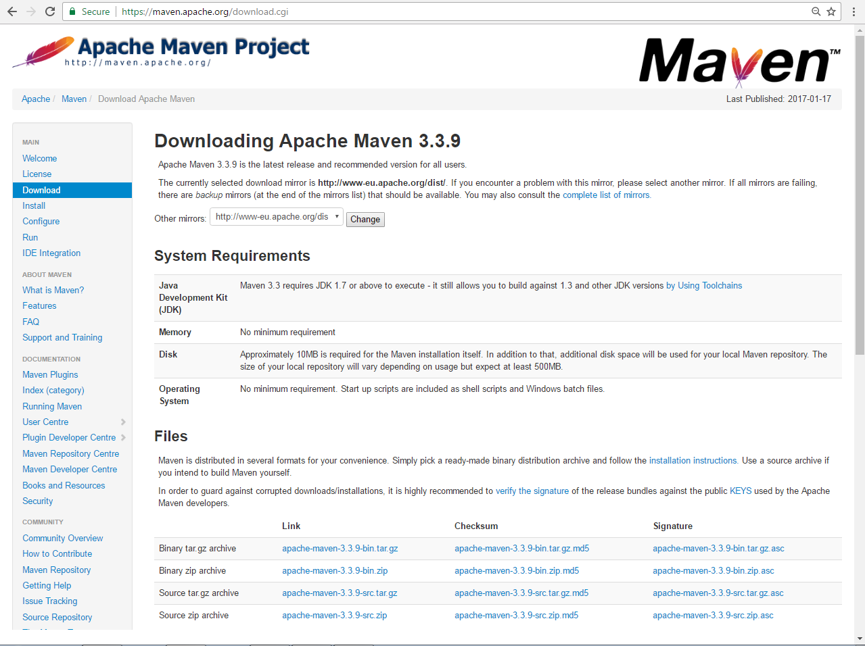

b) While browsing to the site, go to the Files section and download the link to
the Binary.zip file.

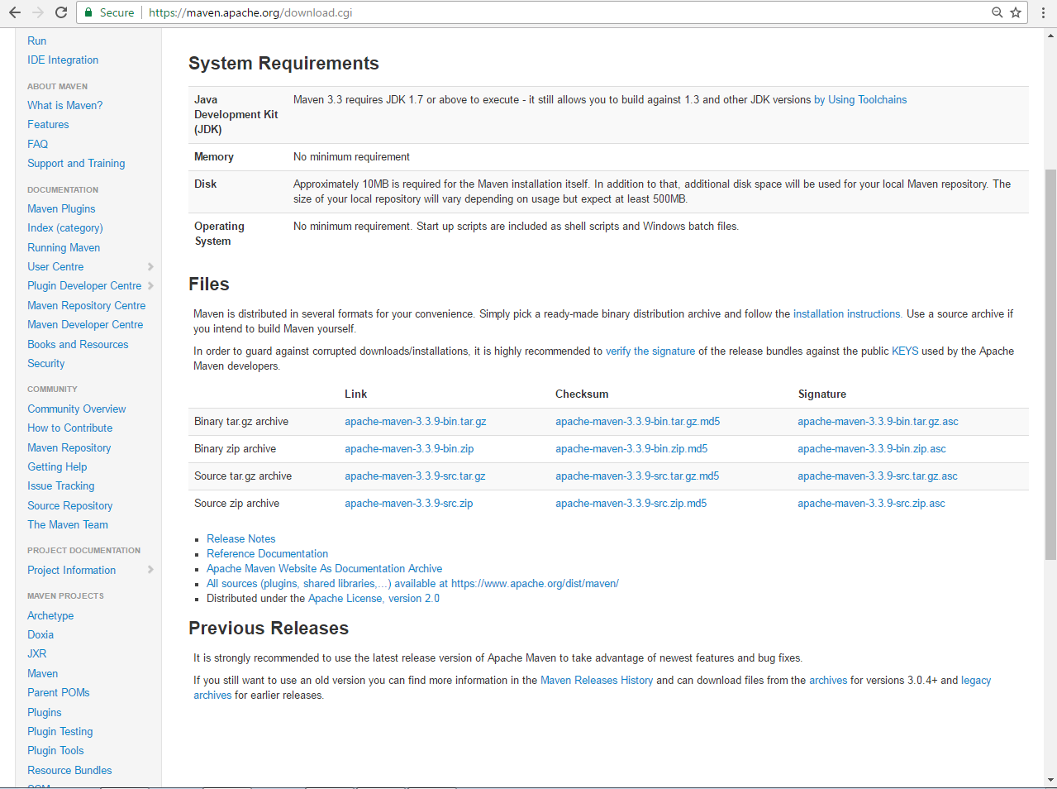

c) Once the file is downloaded, extract the files to the relevant application
folder. For this purpose, I placed the maven files in:
D:\jenkins\apache-maven-3.3.9-bin\apache-maven-3.3.9

Step 2: Setting up Jenkins and Maven

- In the Jenkins dashboard (Home screen), click Manage Jenkins from the left-hand side menu.
- Then, click on ‘Global Tool Configuration’ from the right hand side.

(c)In the Global Team Configuration, scroll down till you see the Maven
section and then
- Click on the ‘Add Maven’ button.
- Uncheck the ‘Install automatically’ option.
- Add any name for the setting and the location of the MAVEN_HOME.
- Then, click on the ‘Save’ button at the end of the screen.

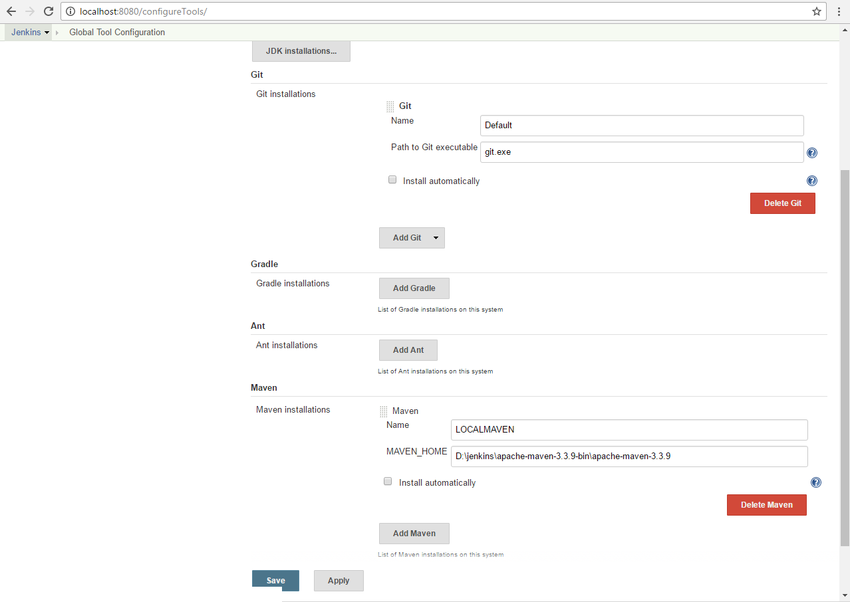

(d)We can now create a job with the ‘Maven project’ option. In the Jenkins
dashboard, click the New Item option.
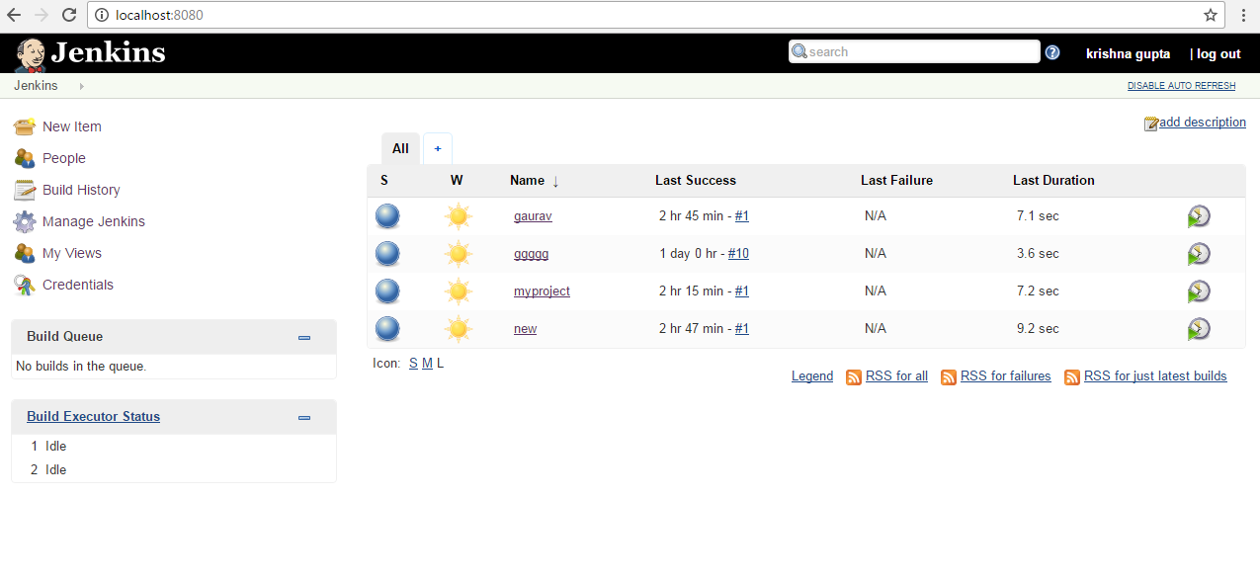
(e) 'Maven project' is available in the list of type of Project/New Item.

